MG’s On Grass 2
31st July 2016
Report by Jim Lott

Once again Dave Coppock had arranged to have this autotest on grass in one of the fields owned by Mr and Mrs Atwell of Claverham Court Farm, Nr. Yatton North Somerset. At his briefing, Dave pointed out that the farmer he had dealt with over the years had sadly died, but the family and his son George, were keen that the event should continue.

Dave had laid out 3 tests for the day and the competitors have five attempts at each test with the worst score being dropped.

The day was sunny and warm, but the grass was quite wet and slippery at the start for the MGFs and TFs with both Neil Lock and myself, pirouetting around the field when a sharp left or right turn was all that was needed!

12 competitors took part, in cars from an MG J2 through to an MG TF160 with a special invitation to Alan Spencer in his MX 5. The results are tabulated on Page 2.
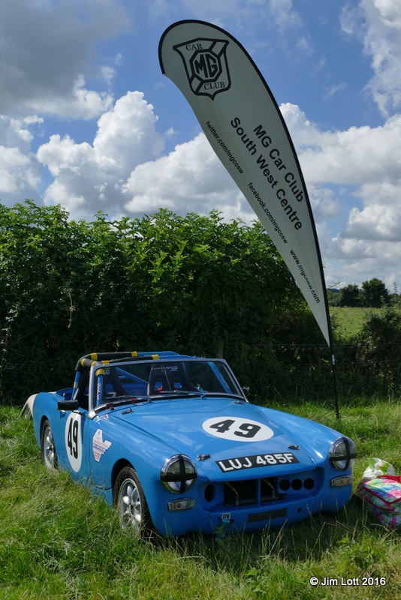
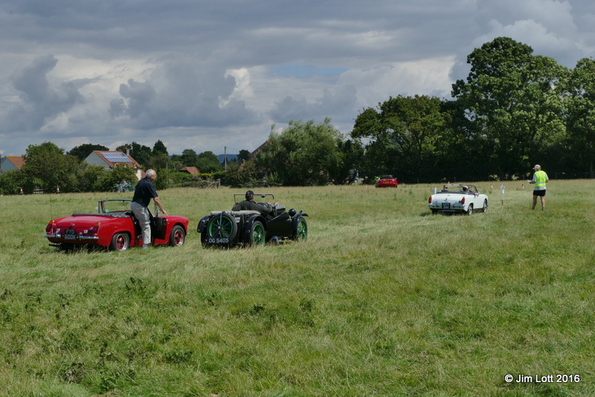
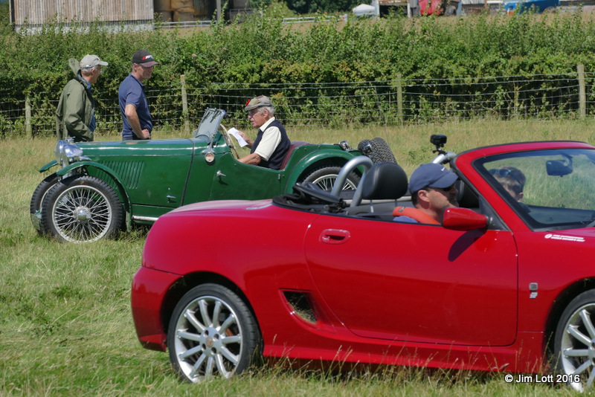

MGs On Grass 2 Results | 31/07/2016
Driver | Car |  | Test 1 |  |  |  |  |  | Test 2 |  |  |  |  |  | Test 3 |  |  |  |  |  | Total
Jeremy Hawke | MG J2 |  | 57 | 63 | 61 | 52 | 50 |  | 75 | 72 | 71 | 66 | 64 |  | 60 | 57 | 56 | 54 | 53 |  | 713 |  | Fastest Time of The Day
Chris Leverett | MG TD Special |  | 105 | 56 | 56 | 103 | 51 |  | 82 | 70 | 64 | 65 | 61 |  | 68 | 56 | 54 | 54 | 54 |  | 744 |  | First in Class, Specials
Kim Dear | MG PB |  | 74 | 63 | 71 | 59 | 58 |  | 76 | 72 | 70 | 68 | x |  | 57 | 57 | 54 | 53 | x |  | 758 |  | First in Class, MMM
Graham Springthorpe | MG Midget |  | 61 | 61 | 58 | 55 | 52 |  | 89 | 80 | 74 | 69 | 68 |  | 111 | 66 | 61 | 59 | 56 |  | 759 |  | First in Class, Midgets
Ian Beningfield | MG Midget |  | 61 | 71 | 70 | 53 | 59 |  | 76 | 72 | 69 | 78 | 68 |  | 82 | 61 | 60 | x | 58 |  | 789
Keith Knight | MG Midget |  | 64 | 63 | 58 | 57 | 54 |  | 81 | 77 | 77 | 73 | 71 |  | 86 | 71 | 73 | 58 | 58 |  | 790
Neil Lock | MG TF |  | 64 | 61 | 62 | 64 | 52 |  | 84 | 79 | 76 | 74 | 68 |  | 90 | 62 | 59 | 59 | 78 |  | 794 |  | First in Class, MGF/MGTF
Alan Spencer | Mazda MX5 |  | 82 | 57 | 58 | 52 | 47 |  | 91 | 117 | 121 | 84 | 78 |  | 71 | 60 | 58 | 56 | 55 |  | 843
Jim Lott | MG F |  | 70 | 64 | 63 | 59 | 74 |  | 104 | 83 | 83 | 80 | 100 |  | 107 | 76 | 59 | 58 | 69 |  | 864
Steve Dear | MG PB |  | 78 | 64 | 64 | 61 | x |  | 85 | 93 | 77 | 80 | x |  | 71 | 76 | 65 | 64 | x |  | 878
Nikki Dear | MG Midget |  |  |  |  |  |  |  |  |  |  |  |  |  |  |  |  |  |  |  | DNF
Chris Dear | MG Midget |  |  |  |  |  |  |  |  |  |  |  |  |  |  |  |  |  |  |  | DNF

