MGs on Grass 7th May 2016

A report by Victoria Jones

It was a glorious day marred only by so few entrants. However this did allow us 5 goes at each test and all done by lunchtime, when we retired to the Catherine Wheel for a couple of hours of good talk, bonhomie and most excellent food. It is just such a shame that we can no longer hold this event under the “Gymkhana” rules as not being able to take passengers round makes it a much less social form of 'entry level' motor sport. Perhaps we should look into this again—what do you think?

Alas, due to pressure of work this year, I didn’t get to send out the customary 2/3 reminders before the event but it is in the calendar, on the web site, in Safety Fast not to mention on the anniversary of last year’s spectacular so, if you didn’t come because you didn’t know when it was being held, you could probably have found out the date all by yourself……..

That over with the results should be attached and all that remains is to thank all the marshals, Margaret Meredith (the lady farmer), Peter (for the 100 mile round trip picking up the bollards and stuff the week before the event) and the competitors who enjoyed the sport.

Results:

 |  | Test 1
John Dellafield | MG Midget | 60 | 59 | 57 | 56 | 55
Dave Mothersdill | MG ZR | 70 | 59 | 58 | 61 | 56
Ben Dellafield | MG Midget | 64 | 61 | 57 | 57 | 55
Peter Jones | MG TC | 63 | 61 | 60 | 62 | 57
Chris Moon | MG TC | 67 | 66 | 62 | 61 | 57
Joseph Moon | MG TC | 75 | 72 | 67 | 65 | 64
Frank Vautier | MG TC | 64 | 65 | 62 | WT | 60
Neil Lock | MG TF160 | 68 | 62 | 75 | 78 | WT

 |  | Test 2
John Dellafield | MG Midget | 77 | 68 | 69 | 69 | 66
Dave Mothersdill | MG ZR | 69 | 70 | 70 | 68 | 67
Ben Dellafield | MG Midget | 82 | 75 | 76 | 66 | 64
Peter Jones | MG TC | WT | 74 | 73 | 72 | 65
Chris Moon | MG TC | 74 | 69 | 70 | 73 | 86
Joseph Moon | MG TC | 78 | 74 | 73 | 73 | 71
Frank Vautier | MG TC | 73 | 77 | 76 | 86 | 74
Neil Lock | MG TF160 | 80 | 83 | 77 | 70 | 69

 |  | Test 3 |  |  |  |  | Total
John Dellafield | MG Midget | WT | 31 | 30 | 30 | 28 | 618
Dave Mothersdill | MG ZR | 32 | 31 | 31 | 30 | 29 | 629
Ben Dellafield | MG Midget | 32 | 34 | 31 | 31 | 27 | 632
Peter Jones | MG TC | 31 | 31 | 31 | 29 | 43 | 646
Chris Moon | MG TC | 35 | 31 | 32 | 30 | 31 | 656
Joseph Moon | MG TC | 41 | 36 | 35 | 34 | 33 | 697
Frank Vautier | MG TC | 36 | 34 | 32 | 38 | WT | 700
Neil Lock | MG TF160 | 37 | 36 | 36 | 31 | 30 | 712

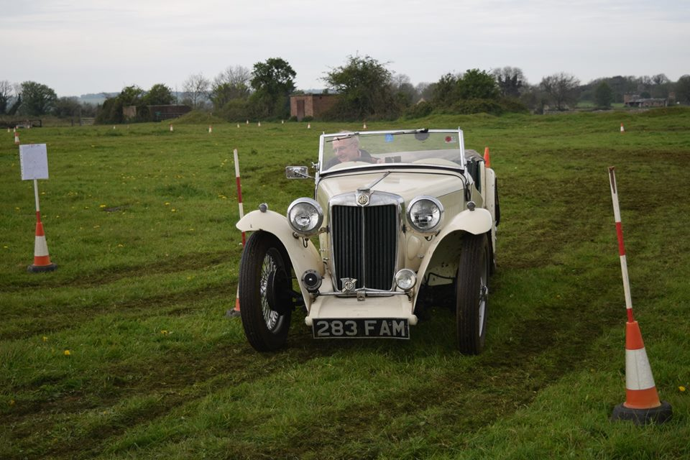
Photos by Oliver Lock
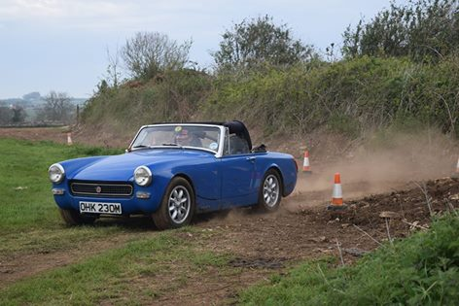
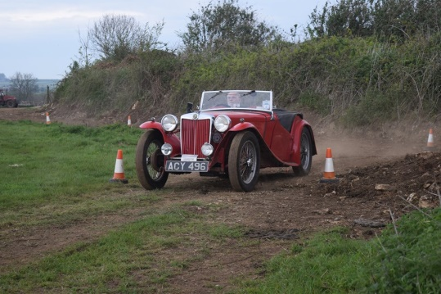
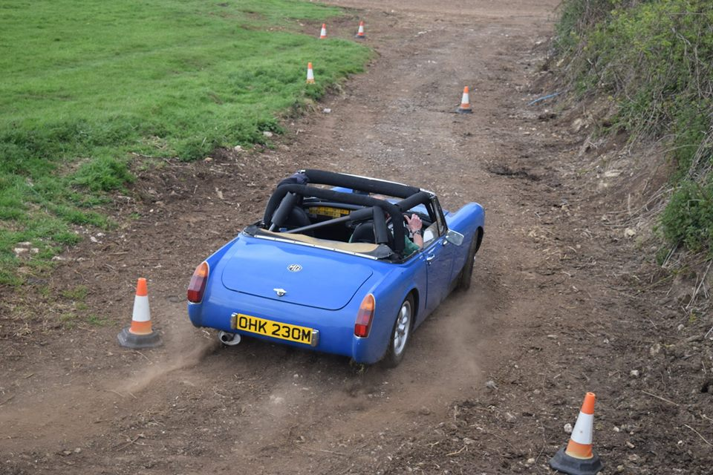
Ben Delafield Chris Moon
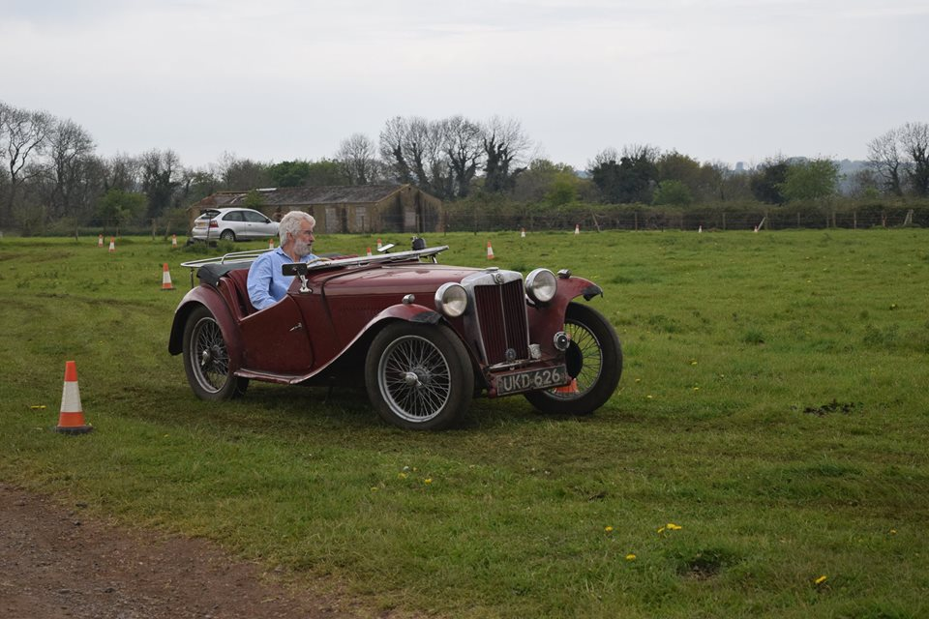
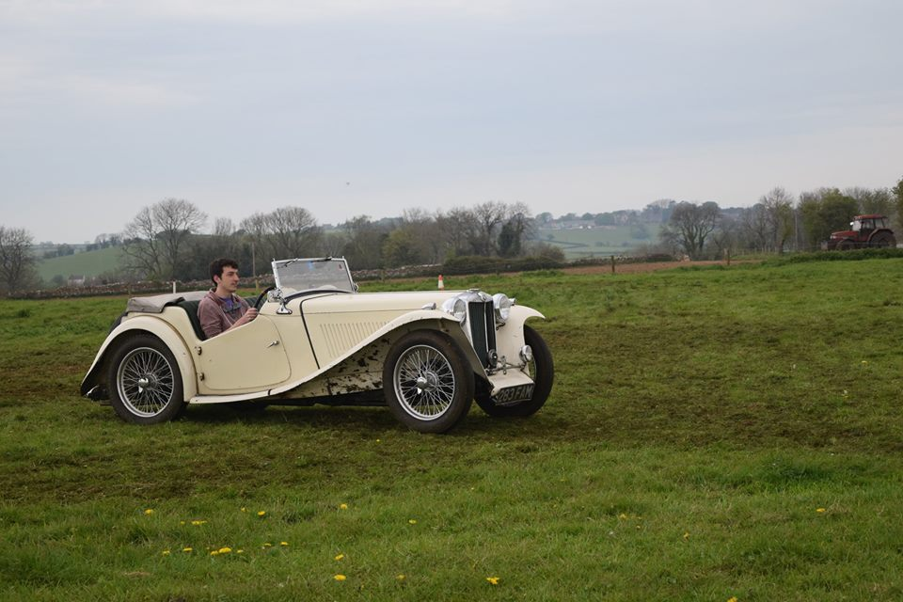
Frank Vautier John Delafield
Joseph Moon Peter Jones

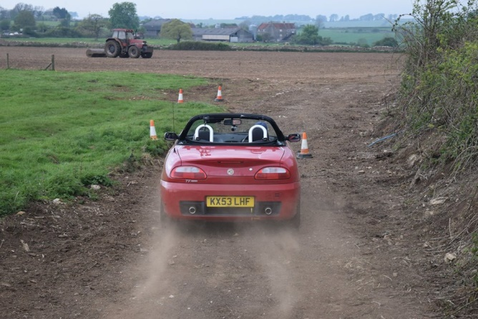

Neil Lock

