Scatter Treasure Hunt

2 July 2017
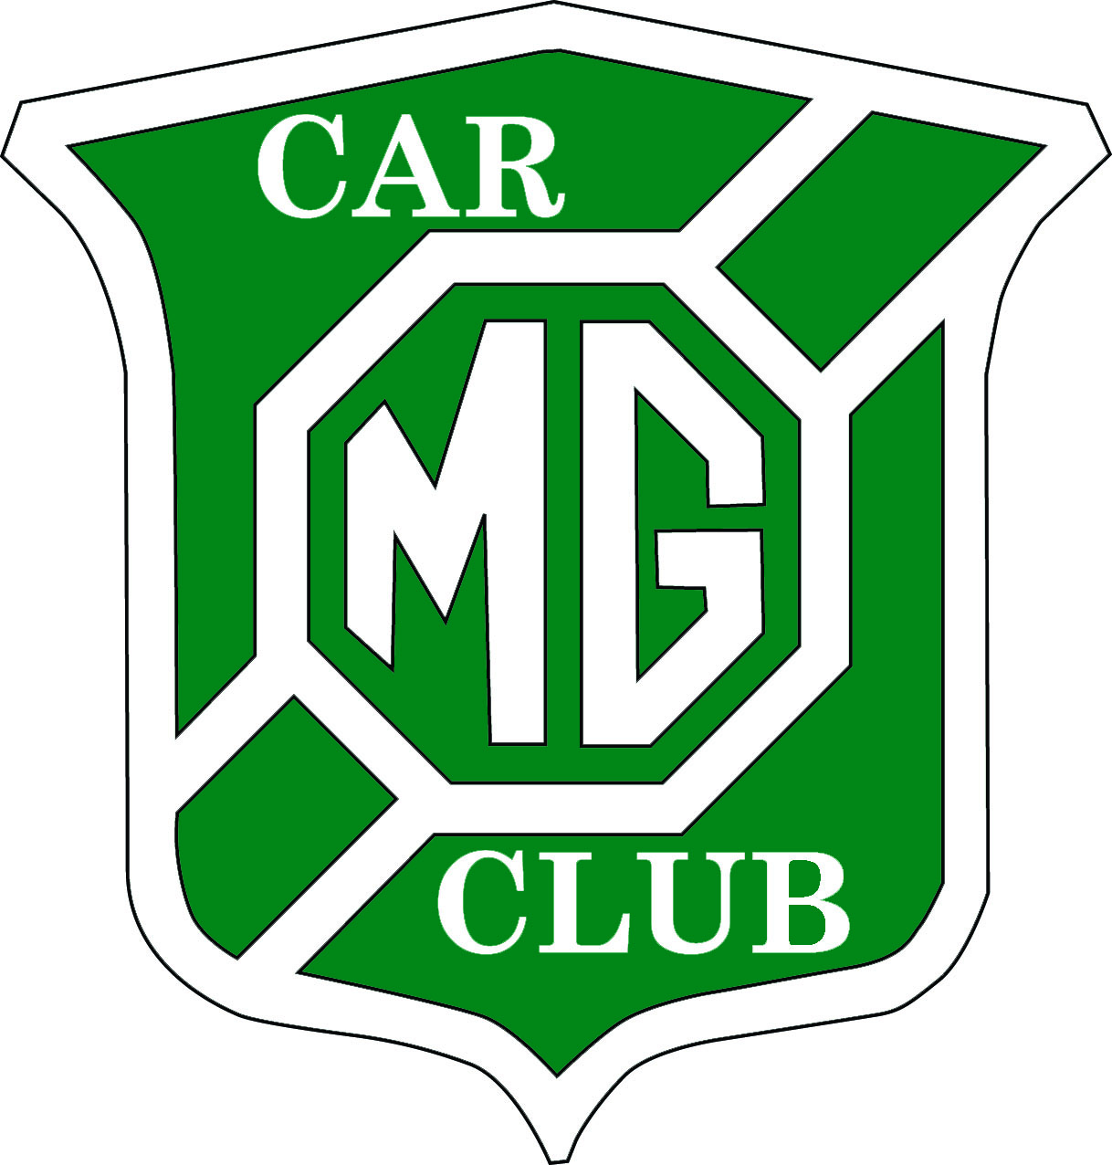
Supplementary Regulations

- The Woolbridge Motor Club Ltd will promote a Scatter Treasure Hunt on
Sunday 2 July 2017 in association with the MG Car Club Ltd.
- The meeting will be held under the General Regulations of the Motor Sports Association (incorporating the provisions of the International Sporting Code of the FIA) and these Supplementary Regulations.
- The event is open to drivers who are members of Woolbridge Motor Club Ltd. and MG Car Club Ltd. Passengers need not be club members. A Permit will be requested from the MSA and displayed at the Start.
- The Start will be at the The Gamekeeper, North Street (A352), Charminster, Dorchester. DT2 9QZ OS Ref. 194 / 679929
Signing-on 10.30am – 11.00am.
- Class 1: Members of Woolbridge Motor Club Ltd
Class 2: Members of the MGCC MGF Register.
Class 3: Members of MGCC SW Centre.
Minimum entry per class is three, minimum for the event is six, maximum 24.
- You will need Ordnance Survey 1:50000 Map 194. (any edition)
Twenty Clue-points can be plotted from a list of Grid References, or simply copied from the Master Map on display at the start venue.
- Entrants will have three hours to plot the clue-points, visit up to fifteen of the twenty clue-points and return to the Finish.
- Determine the clue-points intended to visit and select a route using coloured roads only. For driving purposes all ‘white’ roads are out of bounds. The likely mileage to be covered is in the order of 50 miles.
- At most clue-points it will be necessary to leave the car to find the answer.
- Although there is a time limit, this is not a race, so please drive sensibly, particularly when on narrow rural lanes. Be courteous to other road users, especially those on horseback or bicycles.
- The Finish will be at the The Gamekeeper, Charminster at 2.00pm. A carvery lunch will be available whilst results are computed (not included in the entry fee)
- Lateness at the Finish will be penalised by two marks for every five minutes late or part thereof.
(i.e. one minute late – 2; four minutes late – 2 ; six minutes late – 4)
- Answers at specific clue-points will score 1 point, 2 points, or 3 points as noted on the Master Map.
(Points 1 – 5 = 1pt; Points 6 – 15 = 2pts; Points 16 – 20 = 3 pts).
The first fifteen answers on the scorecard will be used to determine the results, so delete low-scorers if you answer more than fifteen.
- The winning crew in each Class will receive an award or a bottle of wine.
- All entrants who sign on must take Lockton MIS Motorsport third party RTA Cover irrespective of whether they already have cover included in their normal insurance for using their car on the road. The cost is £5 for each car entered.
- Entry Fee will be £9 per car payable at Signing-on, which includes £5 for the above third party car insurance. Any profit from the event will be donated to charity.
- Please e-mail Bob with your intention to enter to social@woolbridge.co.uk with details of your car, it’s registration and crew names, which must be received by Monday 26 June 2017 in order to arrange the mandatory MSA insurance.
After this date a change of car is not then permitted.
- Clerk of the Course: Bob Blackstock - Mobile: 07816218082
- Club Steward; Colin Rolls.

Entry Form:

Driver’s Name | Motor Club
Car Make & Model | Car Registration
Passengers’ Names

Email to social@woolbridge.co.uk

Or post to R. Blackstock, Homelea, Kings Head Hill, Bridport, DT6 3DZ.

Closing Date for entries: 26 June 2017

