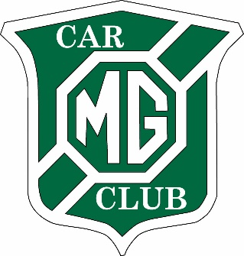 | 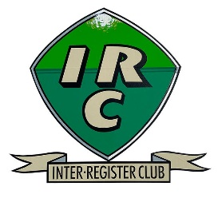  MG Car Club Ltd -  South West Centre  and Inter Register Club  Hereford Navigation Scatter  04 May 2024
ENTRY FORM
Held under the General Regulations of Motorsport UK Ltd (incorporating the provisions of the International Sporting Code of the FIA) and these Supplementary Regulations.

I declare that I have been given the opportunity to read the General Regulations of the Motor Sport UK and the Supplementary Regulations for this event and agree to be bound by them. (www.motorsportuk.org) I declare that I am physically and mentally fit to take part in the event and I am competent to do so. I acknowledge that I understand the nature and type of the competition and the potential risk inherent with motor sport and agree to accept that risk. Further, I understand that all persons having any connection with the promotion and/or organisation and/or conduct of this event are insured against loss or injury caused through their negligence.

I declare the use of this vehicle hereby entered will be covered by insurance as required by the law which is valid for such part of this event as shall take place on roads as defined by the law.

Driver's Name ...........
Address.......................
................................... Postcode….
Telephone No. ...........
E-mail address (for sending Final Instructions & Results) :

Motor Club : Membership No..... Class Entered :

Make, Model & Year of vehicle : Registration No:

Navigator's Name......
Address.......................
................................... Postcode….
Telephone No. ...........
E-mail address (for sending Final Instructions & Results) :

Passenger's Name....
Address.......................
................................... Postcode….
Telephone No. ...........

Passenger's Name….
Address.......................
................................... Postcode….
Telephone No. ...........

Entry Fee £30.00

Passenger details will be retained only for six weeks for Covid trace purposes
Cheques to be made payable to MG CAR CLUB LIMITED – SOUTH WEST CENTRE
Bank transfer to MG CAR CLUB LIMITED – SOUTH WEST CENTRE
Sort Code: - 52-10-48, Account Number:- 04905091, with reference ‘Name’ + Scatter. Please return this form and entry fee to:
Bob Blackstock, 15 Chatsworth Close, Ross-on-Wye, HR9 7XH
or e-mail blackstocks2000@aol.com

