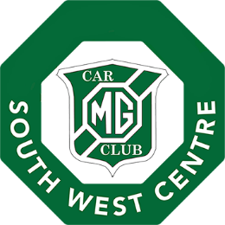
MG Car Club Southwest Centre
Wye-Dean Road Run
21 April 2024

Entry Form

PLEASE PRINT or TYPE DETAILS CLEARLY
Driver | First name |  |  | Surname
Address | Postcode:
Telephone Number
E-mail address
Passenger(s) Name | First name |  |  | Surname
 | First name |  |  | Surname
 | First name |  |  | Surname
Car entered | Make |  |  | Model
 | Reg: |  |  | Year |  | Colour
Interesting or historic details about the car including any interesting owners etc:
Are you a member of a car club? If so, which clubs are you a member?

- Will you be eating in the Hopewell Café yes / no
- Are you planning to take a tour of the caves. Yes / no
Event Entry Fee: Free before 18 April 2023 £5 per car after 18 April 2024
 |  |  |  |  | Total £
Driver’s Signature: Date:
(this confirms that you have a valid driving licence and vehicle insurance and on behalf of all members of the car)
Please save this entry form to computer and then attach to an email and send to: blackstocks2000@aol.com and bring any payment to the Start Documentation.
Alternatively, print and post the entry form to: Bob Blackstock, 15 Chatsworth Close, Ross-on-Wye, HR9 7XH

The latest date for acceptance of free entries is 18 April 2024
If you require postal acceptance of entry, please supply a self-addressed stamped envelope.

