MGCC South West Centre: MG 100 Cavalcade Entry Form
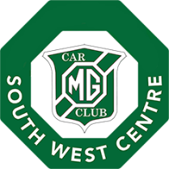

Driver (Print Name): |  |  |  | MGCC membership no:
Driver Signature:

Passenger 1  Name: |  |  |  | Passenger 2  Name:
Car make & model: |  |  | Year: | Registration:
Home address:
 |  |  |  |  | Postcode:
Tel (home): |  |  | (mobile):
Email:

A route book, a Cavalcade Rally Plaque and sticker will be supplied to members entering the Cavalcade.

There is no entry fee for participating in the event, but we hope you will be generous by supporting one, or both, of the very worthy official event charities being Lupus UK and the Alzheimer’s Society. The amount you donate, is of course, entirely at your discretion but we respectfully suggest a minimum of £10 per car. Collection boxes/buckets will be available at the start and finish of the run so please remember to bring some cash!

The SW Centre run is covered by a Motorsport UK Certificate of Exemption for a Touring Assembly, therefore, pre-booking and signing-on are mandatory requirements for insurance cover.

‘Safety Fast!’ March 2024 provides an overview of the entire (JOGLE) event.

The South West Centre website is your ‘go-to’ reference covering all required and anticipated information (https://www.mgccsw.com/event/mg-100-cavalcade-john-ogroats-to-lands-end/

Email your completed entry form to jim.lott@hotmail.co.uk

Closing date for entries: Friday 17th May 2024

